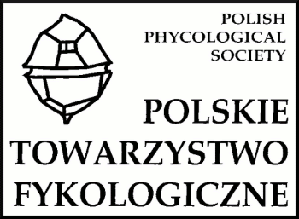

FIRST ANNOUNCEMENT

Polish Phycological Society

Inland Fisheries Institute

Faculty of Environmental Protection and Fisheries
of the University of Warmia and Mazury

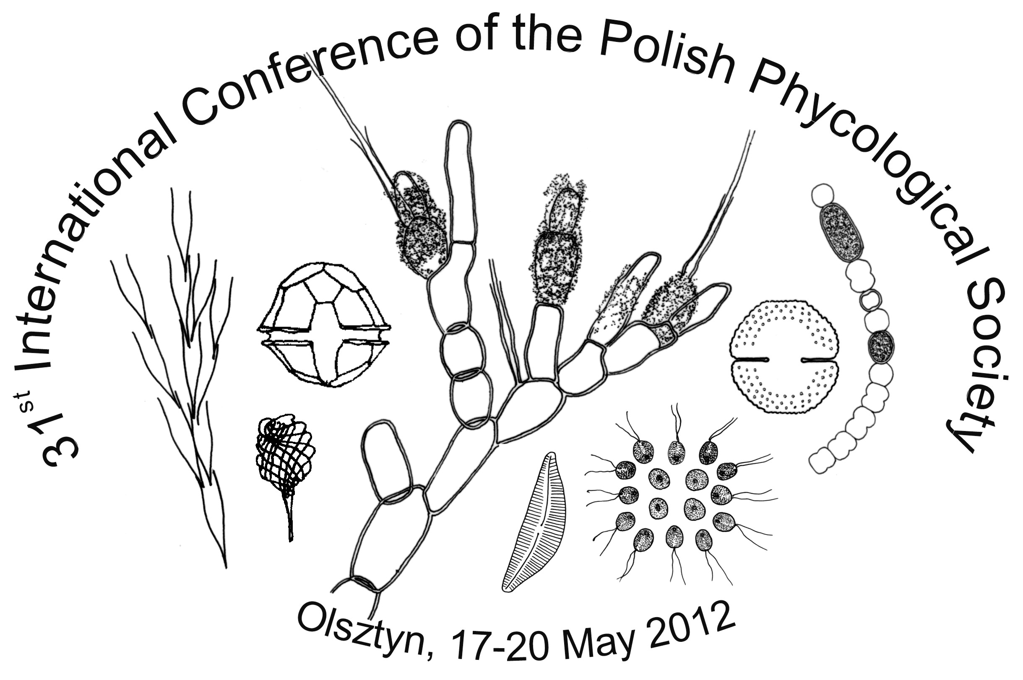

The Organizing Committee
of the 31st International Conference of the Polish Phycological Society
is pleased
to invite you to the Conference organized in Olsztyn

Olsztyn, 17-20th May 2012

„Algae in human’s environment

– taxonomy, ecology and role in ecological status assessment”

„Recent years have witnessed a growing interest in thallophytes for a variety of reasons. In addition to man’s natural propensity to analyze his surroundings for purely scientific reasons, practical considerations are equally important. An understanding of the role played by the tiniest components of the Earth’s biosphere in the functioning of every biological system, including human life and human communities, stimulates research efforts that expand our knowledge about the structure, biology and ecology of the rich world of thallophytes.”
Ryszard Bohr 1984
Rudimentary of phylogenetics and taxonomy of thallophytes

I took the liberty of quoting my Master in the introductory note. The cited motto makes a reference to the human urge to explore the surrounding world – the key driver behind basic and applied scientific research. Until recently, it seemed that the structure, phylogenetics, taxonomy and biology of thallophytes would be the main areas of academic research, and that practical implications would follow from our knowledge of thalloid plant ecology. Meanwhile, the EU Water Framework Directive has placed the Member States under an obligation to achieve at least good ecological status in their water bodies, therefore, evaluations of water quality have taken on a new significance. In order for those analytical efforts to deliver accurate data, we need in-depth knowledge of the ecology of thalloid plants as well new advancements in the area of phycology, including taxonomy. Paleolimnological studies of lake deposits support the identification of changes in the taxonomic composition of diatoms, thus enabling to estimate total phosphorus concentrations and water pH which are fundamental for the determination of reference conditions. Analyses of pigments stored in lake deposits contribute to our knowledge of changes in the composition, abundance and size of algal communities. Reliable reference conditions enable scientists to identify changes that have taken place in aquatic ecosystems over the past decades due to increasing human pressure.
Expanded knowledge of the rich world of thallophytes in all areas of phycological research will open the door for a variety of new practical applications, such as the diatom test in forensic science.

Andrzej Hutorowicz 2012

During the 31st conference of the Polish Phycological Society organizers invite you to present your research in a form of lecture or poster on the following topics:
- taxonomy and morphology of prokaryotic and eukaryotic algae,
- biodiversity, structure and life strategy,
- ecology – autecology and synecology,
- response of algae assemblages to stress conditions of environment,
- algae as indicator organisms,
- the role of algae in ecological status assessment,
- significance of algae for human.

The Conference is held under the auspices of

prof. dr hab. Józef Górniewicz
Rector of University of Warmia and Mazury in Olsztyn

prof. dr hab. Bogusław Zdanowski
Director of the Inland Fisheries Institute in Olsztyn

dr hab. Krystyna Demska-Zakęś, prof UWM
Dean of the Faculty of Environmental Protection and Fisheries UWM in Olsztyn

The Scientific Committee:

prof. Jadwiga Siemińska, prof. Lubomira Burchardt,
prof. Andrzej Hutorowicz, prof. Pertti Eloranta, prof. František Hindák,
prof. Marcin Pliński, prof. Konrad Wołowski, prof. Andrzej Witkowski,
prof. Barbara Rakowska, prof. Barbara Kawecka, prof. Ryszard Gołdyn,
prof. Krzysztof Czernaś, prof. Jan Matuła,

Organizing Committee:

prof. dr hab. Andrzej Hutorowicz
dr inż. Bożena Jaworska
dr inż. Agnieszka Napiórkowska-Krzebietke

e-mail: fykol@infish.com.pl
website: http://www.amu.edu.pl/~fykolog

Preliminary programme of 31st International Conference of the Polish Phycological Society, Olsztyn 17-20th May 2012

Thursday, 17th May 2012

09:00 – 14:00 – Registration
12:00 – 12:30 – Opening Ceremony of the Conference
12:30 – 14:30 – Plenary session
15:00 – 16:00 – Lunch
17:00 – 19:00 – Olsztyn sightseeing
19:00 – 19:30 – Journey to Leśne Wrota resort
19:30 – 20:30 – Registration in the hotel
20:30 – 21:00 – Supper

Friday, 18th May 2012
08:00 – 09:00 – Breakfast
09:00 – 14:00 – Plenary session
14:00 – 15:30 – Lunch
15:30 – 16:30 – Poster session by the coffee
16:30 – 18:00 – Plenary session
20:00 – ……. – Bonfire

Saturday, 19th May 2012
08:00 – 09:00 – Breakfast
09:00 – 14:00 – Plenary session
14:00 – 15:30 – Lunch
15:30 – 16:30 – Poster session by the coffee
16:30 – 18:00 – Meeting of the Polish Phycological Society
20:00 – ……. – The festive supper

Sunday, 20th May 2012
08:00 – 09:00 – Breakfast
09:00 – Journey back from Leśne Wrota Resort to Olsztyn railway station

Important information

- Registration forms should be sent before 30th January 2012; either by e-mail: fykol@infish.com.pl or fax: + 48 89 524 05 05 or post to the secretary Agnieszka Napiórkowska-Krzebietke Ph.D., Department of Hydrobiology, Inland Fisheries Institute in Olsztyn, Oczapowskiego 10, 10-719 Olsztyn, Poland.
- Abstract instruction will be sent in the second announcement.
- The second announcement will be sent only to people who have confirmed their participation in the Conference.
- Conference fee is 350 PLN (Polish currency) and covers i.e. conference materials, welcoming treat and lunch in the first day of the Conference, transport (by bus) Olsztyn-“Leśne Wrota Resort”-Olsztyn.
- Estimated cost of the participation in the Conference should not overdraw 1000 PLN, including 350 PLN – conference fee and about 600 PLN – cost of living.
- Further information will be sent in the second announcement.

The conference organizers ask for sending this announcement to everybody who is interested in.

Organizing Committee

Registration Form

31st International Conference of the Polish Phycological Society

„Algae in human’s environment
– taxonomy, ecology and role in ecological status assessment”

Olsztyn, Poland, 17-20th May 2012

First name: ................................................................................................................................
Last name/Family name:........…................................................................................................
Science degree:...........................................................................................................................

Company/Institution:…………..........................................................................…....................
Postal Address:……….…..........................................................................................................
Phone/Fax:..................................................................................................................................
e-mail:.........................................................................................................................................

Preference for presentation:

Lecture .......... short lecture ............ poster ...............

The title of lecture or poster:
…………………………….……………………………………………………….…………....
………………………………………………………………………………...………...………
…………………………………………………………………………………………………..
………………………………………………………………………………………………..…
………………………………..…………………………………………………………………
…………………………………………………………………………………………………..

Plenary session will be includes lecture 20 minutes and short lecture 15 minutes (in both cases including the discussion)

e-mail: fykol@infish.com.pl

